St. Edward’s Episcopal Church

Holy Eucharist
The Fifth Sunday of Easter – Year B
Sunday, April 28, 2024 @ 10 a.m.

Our Vision
We are a community of faith where all are welcome to live and share Christ
with love, commitment, and compassion.

Our Mission
In our rich Episcopal tradition, embracing diversity of cultures and languages,
we empower discipleship to Christ through worship, formation, and service.

If you are visiting with us today, please fill out a Visitor Card and give it to one of our ushers, so we can send you more information about our church. It is customary to stand during the singing of hymns. Either stand, sit, or kneel for prayers. We are blessed that you are here, and we look forward to meeting you!

Prelude

Processional Love divine, all loves excelling Blue Hymnal 657
All stand, if able

Opening Acclamation BCP 355
Presider: Alleluia. Christ is risen.
People: The Lord is risen indeed. Alleluia.

Gloria in Excelsis Glory to God in the highest Blue Hymnal S-280

Collect of the Day
Celebrant The Lord be with you.
People And also with you.
Presider: Let us pray.
Almighty God, whom truly to know is everlasting life: Grant us so perfectly to know your Son Jesus Christ to be the way, the truth, and the life, that we may steadfastly follow his steps in the way that leads to eternal life; through Jesus Christ your Son our Lord, who lives and reigns with you, in the unity of the Holy Spirit, one God, for ever and ever. Amen.

The Word of God

The First Reading Acts 8:26-40
A Lesson from the Book of Acts
An angel of the Lord said to Philip, “Get up and go toward the south to the road that goes down from Jerusalem to Gaza.” (This is a wilderness road.) So, he got up and went. Now there was an Ethiopian eunuch, a court official of the Candace, queen of the Ethiopians, in charge of her entire treasury. He had come to Jerusalem to worship and was returning home; seated in his chariot, he was reading the prophet Isaiah. Then the Spirit said to Philip, “Go over to this chariot and join it.” So Philip ran up to it and heard him reading the prophet Isaiah. He asked, “Do you understand what you are reading?” He replied, “How can I, unless someone guides me?” And he invited Philip to get in and sit beside him. Now the passage of the scripture that he was reading was this: “Like a sheep he was led to the slaughter, and like a lamb silent before its shearer, so he does not open his mouth. In his humiliation justice was denied him. Who can describe his generation? For his life is taken away from the earth.” The eunuch asked Philip, “About whom, may I ask you, does the prophet say this, about himself or about someone else?” Then Philip began to speak, and starting with this scripture, he proclaimed to him the good news about Jesus. As they were going along the road, they came to some water; and the eunuch said, “Look, here is water! What is to prevent me from being baptized?” He commanded the chariot to stop, and both of them, Philip and the eunuch, went down into the water, and Philip baptized him. When they came up out of the water, the Spirit of the Lord snatched Philip away; the eunuch saw him no more and went on his way rejoicing. But Philip found himself at Azotus, and as he was passing through the region, he proclaimed the good news to all the towns until he came to Caesarea.

Lector: The Word of the Lord.
People: Thanks be to God.

Psalm 22:24-30 The Lector reads the verses; the People sing the Refrain.
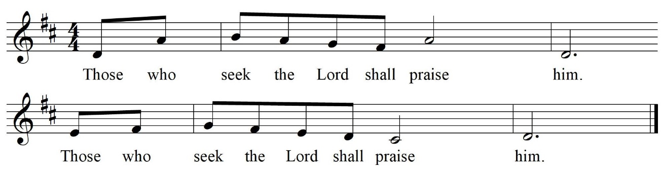
Refrain

24 My praise is of him in the great assembly; *
I will perform my vows in the presence of those who worship him.
25 The poor shall eat and be satisfied,
and those who seek the Lord shall praise him: *
"May your heart live for ever!" Refrain

26 All the ends of the earth shall remember and turn to the Lord, *
and all the families of the nations shall bow before him.
27 For kingship belongs to the Lord; *
he rules over the nations.
28 To him alone all who sleep in the earth bow down in worship; *
all who go down to the dust fall before him. Refrain

29 My soul shall live for him;
my descendants shall serve him; *
they shall be known as the Lord's for ever.
30 They shall come and make known to a people yet unborn *
the saving deeds that he has done. Refrain

THE EPISTLE 1 John 4:7-21
A Lesson from the 1st Letter of John (pre-recorded)
Beloved, let us love one another, because love is from God; everyone who loves is born of God and knows God. Whoever does not love does not know God, for God is love. God's love was revealed among us in this way: God sent his only Son into the world so that we might live through him. In this is love, not that we loved God but that he loved us and sent his Son to be the atoning sacrifice for our sins. Beloved, since God loved us so much, we also ought to love one another. No one has ever seen God; if we love one another, God lives in us, and his love is perfected in us. By this we know that we abide in him and he in us, because he has given us of his Spirit. And we have seen and do testify that the Father has sent his Son as the Savior of the world. God abides in those who confess that Jesus is the Son of God, and they abide in God. So we have known and believe the love that God has for us. God is love, and those who abide in love abide in God, and God abides in them. Love has been perfected among us in this: that we may have boldness on the day of judgment, because as he is, so are we in this world. There is no fear in love, but perfect love casts out fear; for fear has to do with punishment, and whoever fears has not reached perfection in love. We love because he first loved us. Those who say, "I love God," and hate their brothers or sisters, are liars; for those who do not love a brother or sister whom they have seen, cannot love God whom they have not seen. The commandment we have from him is this: those who love God must love their brothers and sisters also.
Presider: The Word of the Lord.
People: Thanks be to God.

Sequence Hymn He came down (From the Iona Community)
Please stand, if able.
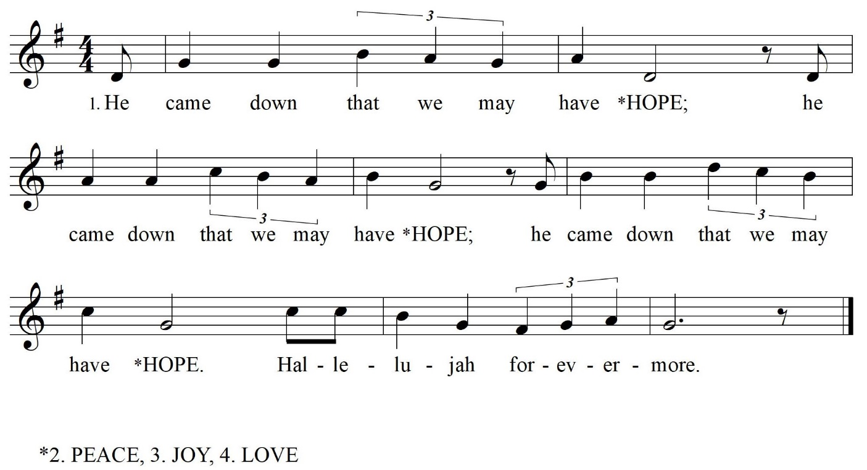

The Gospel Reading John 15:1-8
Presider: The Holy Gospel of our Lord Jesus Christ according to John.
People: Glory to You, Lord Christ.
Jesus said to his disciples, ”I am the true vine, and my Father is the vine grower. He removes every branch in me that bears no fruit. Every branch that bears fruit he prunes to make it bear more fruit. You have already been cleansed by the word that I have spoken to you. Abide in me as I abide in you. Just as the branch cannot bear fruit by itself unless it abides in the vine, neither can you unless you abide in me. I am the vine, you are the branches. Those who abide in me and I in them bear much fruit, because apart from me you can do nothing. Whoever does not abide in me is thrown away like a branch and withers; such branches are gathered, thrown into the fire, and burned. If you abide in me, and my words abide in you, ask for whatever you wish, and it will be done for you. My Father is glorified by this, that you bear much fruit and become my disciples.”
Presider: This is the Gospel of the Lord.
People: Praise to You, Lord Christ.

The Sermon Rev. Fabio Sotelo

Nicene Creed BCP 358

The Prayers of the People

Presider: As branches of Jesus, the living Vine, abiding in the Spirit of love, we bring our prayers to God: Eternal Loving One, accept the wishes of our hearts as we pray faithfully: For God is love; and perfect love casts out all fear.

Litanist: Gracious One, you have called us to abide in your life and to bear witness to Christ the Lamb: Grant that the Church may reveal your love through Jesus, that we might live in him and bear good fruit. For God is love,
and perfect love casts out all fear.

Light of the Word, dominion belongs to you, for you rule over the nations: Raise up for your Church bold witnesses like Philip who will testify to the rich and powerful about God's good news which is perfected in love, so that peace may abound in our time. For God is love,
and perfect love casts out all fear.

Attentive Vinegrower, you tend the branches and fruit of your vineyard extending to the ends of the earth: Let your loving attention reach out to all people who live in suffering and threatening conditions, that they may be restored to life and fruitfulness. For God is love,
and perfect love casts out all fear.

Accept our grateful thanks for your abundance in our lives, especially for the birthdays of Lorenzo Clarke, Keira Woodward, Pauline Tweh, Lucy Herrera, Blair Gatland, and Darcey Tatum, and the anniversaries of Tim & Kecia Klob and Patrick and Ruth Mannah . (The congregation may add their own petitions) For God is love,
and perfect love casts out all fear.

You have first loved us and called us to love our neighbor as ourselves. Hear our prayers for all for whom we intercede: Bishop Curry, Shandi, Blanding, Adolphus, Billy, Carla, Craig, Cindy, David, Rosemary, Holly, Eric, Charlie, Renita, Rafael, Kathy, Barku, Rick and Julia, Bradford, Vernelle, Diane, John & Michelle, Elizabeth, Cynthia, Sharon, Charles, Vinnie, Denise, Marian, Linda, Keriel, for the victims of the wars in Israel, Palestine, Gaza, and Ukraine. (The congregation may add their own petitions) For God is love,
and perfect love casts out all fear.

Gather into your banquet all who have died, may their hearts live forever! (The congregation may add their own petitions) For God is love,
and perfect love casts out all fear.

Presider: You have planted us in the nurturing ground of your steadfast love, O God, and grafted us into the life of your resurrected Son, Jesus: Keep us evermore abiding within your Spirit of love, that we may bear the fruit of reconciliation for all that is and is to come, through Jesus Christ our Savior. Amen.

The Peace BCP 360
Presider: The peace of the Lord be always with you.
People: And also with you.

THE HOLY COMMUNION

Offertory sentence
Presider: Walk in love, as Christ loved us and gave himself for us, an offering and sacrifice to God. (Ephesians 5:2)
Journey to Gratitude
If you have returned your pledge card, we want to thank you. If you have not, it is not late to do it. please fill out a pledge card you will find in the pews and place it in the collection plate. Thank you for supporting God’s work.

Offertory In this very room Parish Choir
Ron & Carol Harris

Presentation Hymn God is love Blue Hymnal 379
Please stand, if able.

The Great Thanksgiving: Eucharistic Prayer B BCP 367

The Sanctus Holy, holy, holy Lord Blue Hymnal S-125

The Lord’s Prayer BCP 364
And now, as our Savior Christ has taught us, we are bold to say:

The Breaking of the Bread BCP 365

Fraction Anthem Eat this bread (From Taizé)
Eat this bread, drink this cup, come to him and never be hungry,
Eat this bread, drink this cup, trust in him and you will not thirst.
Come el pan, bebe el vino, ven a el y no tendrás hambre,
Come el pan, bebe el vino, cree en el y no tendrás sed.

The Invitation The Gifts of God for the People of God.
Communion is offered in both kinds by intinction. You are invited to take the host from the hands of the minister.
Gluten free wafer available upon request.

Communion Hymns From the following, as time permits.
I am the vine, and you the branches Parish Choir
Come, my way, my truth, my life Blue Hymnal 487

Sending Forth the Eucharistic Visitor
Presider: We send you forth bearing this Holy Gifts, that those to whom we go
may share with us in the mystery of the present of Christ our Lord.
People: We who are many are one body because we share one bread, one cup.
Amen.

Postcommunion Prayer BCP 365

Notices

THE BLESSING
God is love, and perfect love casts out fear. Fear not, and love one another, because love is from God. Abide in Christ as Christ abides in you and bear much fruit as his beloved disciples. By this you know that you abide in God and God abides in you, because God has given you the Holy Spirit. And the blessing of our loving God, the Father, the Son and the Holy Spirit, be with you and abide in you, now and for ever. Amen.

Recessional Hymn We know that Christ is raised Blue Hymnal 296
Please stand, if able.

The Dismissal
Presider: Alleluia, Alleluia. Let us go forth into the world, rejoicing in the power and gift of the Risen Lord and Savior.
People: Thanks be to God. Alleluia, Alleluia!

Postlude

Please join us at the Altar Rail for healing.

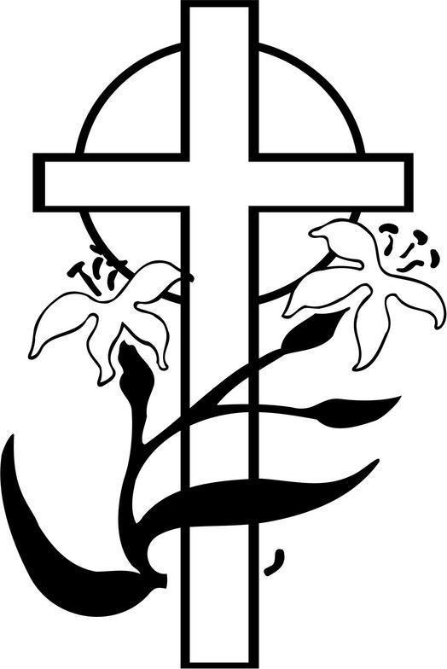

The Vestry and Staff of St. Edward’s thank you for worshiping with us today.
We pray God’s blessings upon you this Eastertide!

St. Edward’s Episcopal Church  737 Moon Road  P. O. Box 351  Lawrenceville, GA. 30046  Phone: 770-963-61289  www.StEds.love  Serving Today  Preacher & Presider – The Rev. Fabio Sotelo  Verger - Leslie Nystrom  Altar Guild - Jewel Ffrench, Denise Robinson  Altar Bread – Mary Lu & Charles Rogers  Flowers – Flower Guild  Crucifer – John Nystrom  Torches – Valerie Curry, Chaz Alexander  Eucharistic Ministers – Mary Christopher,  Samantha Toomey  Eucharistic Visitor - Samantha Toomey  Healing Minister – John Nystrom  1st. Reading – Jovita Deshield  Psalm - Choir  2nd. Reading – Vanya Davis (pre-recorded)  Intercessor – Darren Harris  Ushers – Brenda Tamb-Dahn, Ruth & Patrick Mannah, Eric Wespheling  Sound & Video - Mike Staub  Piano & Organ – Carla Strott  Flutes – Sanya Simmons & Lee Ann Sipe  Guitar – Rich Van Slyke  St. Edward’s Parish Choir  Vestry Person of the Day – Alma Hurtado  Parish Personnel  The Rt. Rev. Robert C. Wright, Diocesan Bishop  The Rev. Fabio Sotelo, Priest-in-Charge  Leslie Nystrom, Parish Administrator  Leslie Nystrom, Verger  Carla Strott, Director of Music  Ted Ruchalski, Media Engineer & Technology Consultant  William Paasewe, Treasurer  Diane Van Slyke, Assistant Treasurer  Magalie Nemorin-Nonez, Bookkeeper  Nicole Harrison, Chancellor  The Vestry of Saint Edward’s  Jennifer Khaleel, Senior Warden  Alma Hurtado, Junior Warden  Marck A. Morman, Erica Harris, Valerie Curry, Brendalyne Tamba-Dahn, Cecilia Midzi,  Martha Cuenca, Teresa Guzmán, Ruth Mannah, Darcey Tatum, Lorenzo Clarke.  Mary Lu Rogers, Clerk of the Vestry | Those wishing to donate flowers are asked to contact the parish office @ 770-963-6128 or via email: parishadmin@stedwardsonline.org  Permissions  Copied and streamed under OneLicense.net #A-725723: Glory to God in the highest, Tune: Robert J Powell © 1985, Church Publishing, Inc.; He came down, John L. Bell, © 1990, Iona Community, GIA Publications, Inc.; In this very room, Ron and Carol Harris © 1979, Ron Harris Music; God is love, let heaven adore him, Tune - Abbot's Leigh: Cyril V Taylor © 1970 Hope Publishing Company; Sanctus, Setting: Richard T Proulx © 1971, 1977, GIA Publications, Inc.; Eat this bread, Jacques Berthier & the Taizé Community © 1984, Les Presses de Taizé, GIA Publications, Inc.; I am the vine, © 1995, WGRG c/o Iona Community, GIA Publications, Inc.; We know that Christ is raised, Text: John Brownlow Geyer © 1982, Church Publishing, Inc.

